Story Mapping Sessions  
~David Hussman (devJam)

**Story Mapping -** tool used to help teams visualize the user experience so they can better understand the users needs.

* Product Owners in SCRUM are very valuable
* Context matters
  + “Why are you doing something?”

**Challenges/Issues:**

1. Index cards *without* context (As a _____ I need to _____ so I can) is not acceptable anymore.
   1. Replace with “**Persona’s**”
   2. **Persona’s** help us to stay “User Centered”
   3. Start much richer discussions using user-centered thinking.
2. Having no product road map
3. Generic statement by the business, “let’s put things into Production in 30 days.” Roadmap needs to be meaningful. **You have to know where you’re going.**
4. We need to get started mentality (that’s why EPICS were created)
   1. Epics get broke-down into smaller things, but no product owner says, “I want something that’s big”.
   2. Solution is to use cross-cutting not hierarchical mapping

**Story Maps**

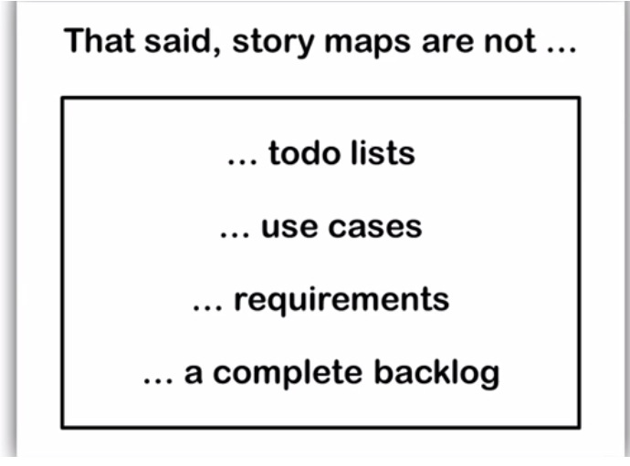

**Story Cards**

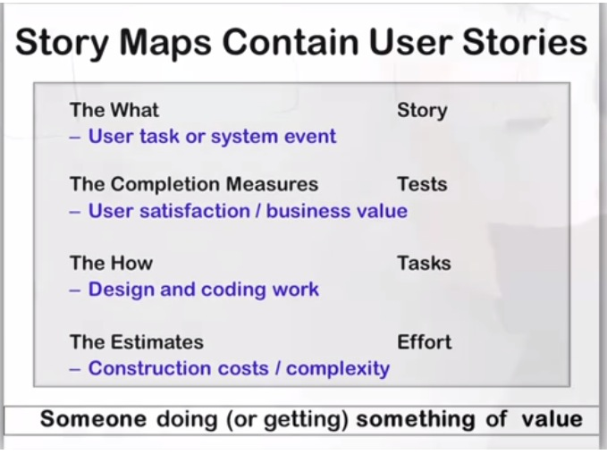

1. Front of the Card – Discovery Side
   1. Story Title: What do you want to do?
   2. What **value** are you delivering?
   3. What is the Core Set of Tests – set of tests that allow the team to “move on”.
      1. Acceptance Tests – Happy Path
      2. Negative Tests
2. Back of the Card
   1. Delivery
   2. Tasking
   3. User Tasks

**Process:**

* “What” should be =< 5 words
* We are not getting rid of stories; we just want to put it together in a visual way to tell one story. What is often missing is the **context** piece, which is what we are trying to get at.
* Build out a story map without making it too big
* Product thinking vs. delivery thinking
* Product owners care if they can **DO** something, so value is added when they can **DO** something. Do we have product we can put in front of a user getting meaningful feedback? Goal is to have at least one path through.
* ***Do not*** feel we have to “get it right” the first time. That ruins the creative, improve, flow, and the vibe.

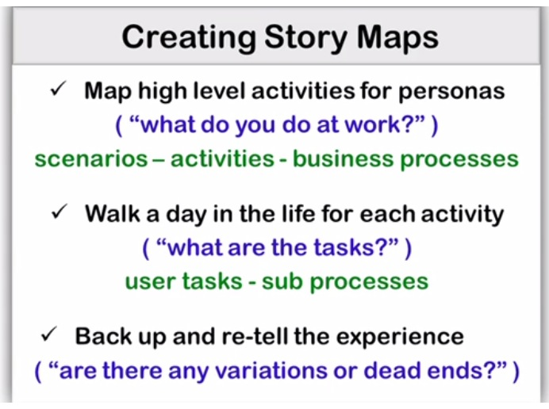

Story Mapping

* Product Owner wants EVERYING
* Similar to Business Process Modeling except the **user is not forgotten.**
* Two Rules:
  + Mile Wide/Inch Deep  
    **aka**
  + More writing/Less talking (there should not be a lot of talking, talking, talking)

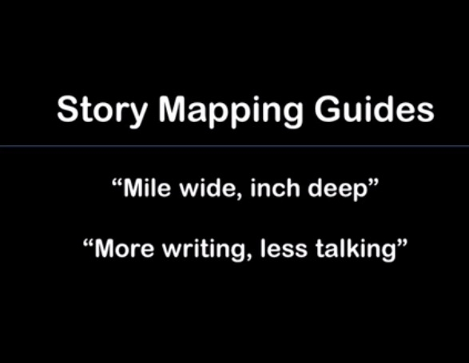

**Story Map Example.**

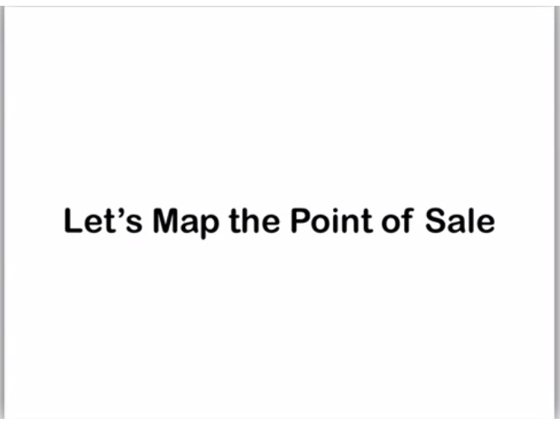

**Goals**

* Log In/Log Out
* Check people out/make sales
* Negative
  + Process Returns
  + Process Exchange

Mile Wide/Inch Deep –choose one thing. Basic things cashier need to do.

* Choose the basic things cashier has to do.
* Scans Item > Calculates Total > Takes Payment > Prints a Receipt > Tax
* No Deep Ending!
* **Variations:** Sometimes SME says two things are the same thing.
  + We get rid of subtasks and focus on the core task.
  + For example; scan item or key-in item is the same core tasks which is enter the item

**Story Map is a Tool.**

* Helps visualize the user experience fast even in complex problems
* Can use sketches to supplement – can tie visualize representation to process
* Software Cartography ;-)
  + Building out the map so we know where we’re going > next> how do we get there?
  + Delivery piece > User Tasks
  + Crude version of skilled things in the design space
  + More complex tasks **cannot** be divorced from what can be more practical for teams
* Large Group can interact with it from multiple perspectives
* Describes the User Experience – beginning of a Test Plan
  + Story Maps are spawn test plans
  + Paths are tests
  + Beginning user documentation
  + Example: Router documentation (1) connect to Internet, (2) secure connection, (3) etc.
* Connecting the (1) product people (2) delivery people (3) testing group (4) UX user experience people
* We to know **WHERE** we are going so we can focus on **HOW** to get there

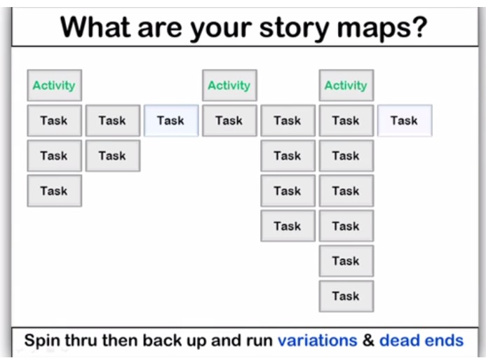

***NOTE: Still missing next steps: start up costs, build, environmental impact, etc.***

**Cross Team Mapping.**

* Story map can show how to move from System A to System B inside a map
* Example Producer (Car Engine Team) needs to talk to the Consumer (Car)
  + Needs to be user-centered. Let’s lets make car engine decisions based on use
  + The goal of a Story Map and what is important is to go End to end in a user experience is the goal.
* Happy path and variations
* This is what is most important to the Product Manager.

**Last list in Story Mapping.**

* Concrete
* Architectural Spikes
* Continuous Integration, Continuous Deployment, Development and QA environment
* Fixed set of investment for researching: options and possibly estimates, with a trust boundary
* Aka technical debt
* Story Mapping allows people to learn

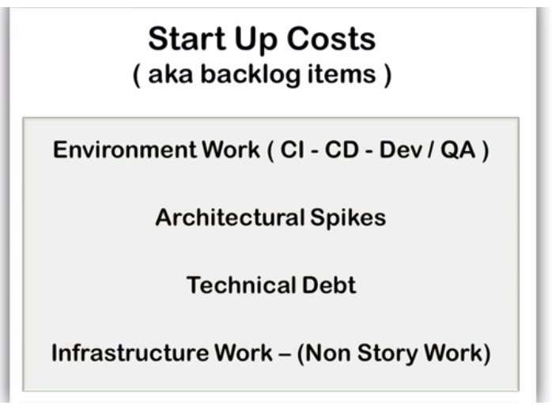

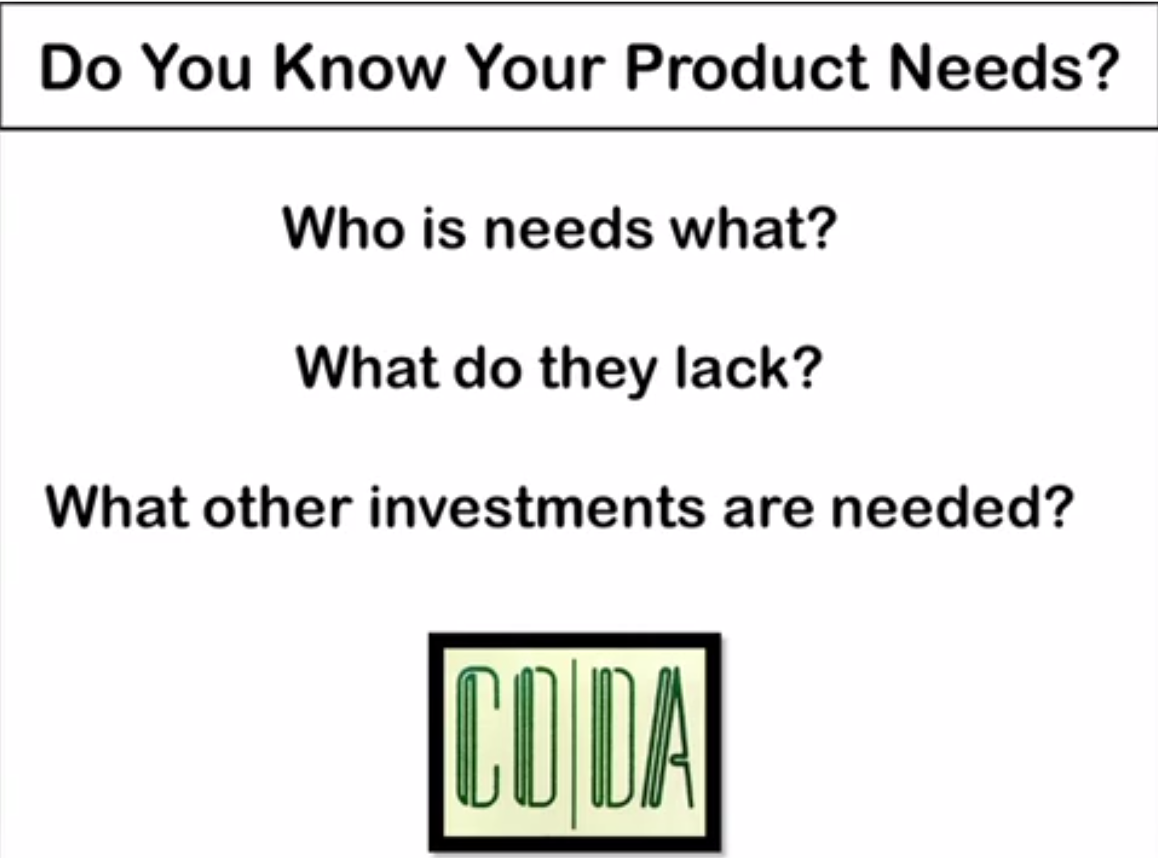

* If you know someone who has all this information, you can blast through this quickly
* If you cannot find the answers, then you should not start sprinting toward the iteration

**Questions/Answer Statements**

* Story mapping is better than epics because they do not allow iterations go out of control. Empirically, people are not learning from their epic mistakes. They are not using their trending data
* If a task is a significant event but it’s not a development task, then someone is going to ask, “Where is tax going”? So it’s something that will not slide by domain experts. The work has to go somewhere and all that work could be consumed in another task even if it’s not a user task, it is a-synchronicity
* In a headless system (document management) those are steps the user wants they just do not request them so there still is a User.
* How deep to you go? You put a questions mark or “…” after the 3rd level, try to discuss tasks. **The more detail you right the worse tests you come up with!**
* “It’s what you don’t know that hurts most.” ~Naseem Talib